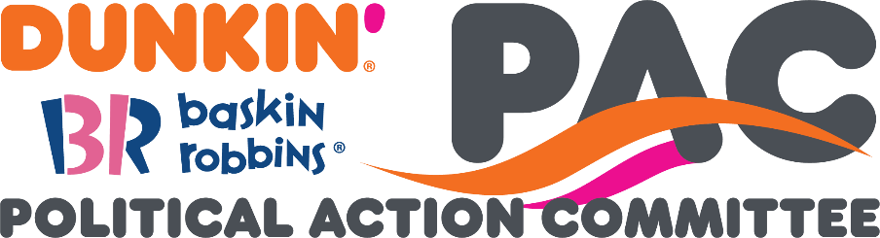

Payroll Deduction Form

|  |  |  |
| --- | --- | --- |
| **Suggested Giving Levels** | | |
| **Title** | **Bi-Weekly Deduction Amount** | **Annualized Deduction Amount** |
| Manager *(band 6 or above, not OT eligible)* | $5 | $130 |
| Senior Manager | $10 | $260 |
| Director | $15 | $390 |
| Sr. Director | $20 | $520 |
| Vice President | $40 | $1,040 |
| SVP | $50 | $1,300 |
| Leadership Team | $100 | $2,600 |

|  |  |
| --- | --- |
| Name | *Name* |
| Title | *Title* |
| Address | *Address* |
| Bi-Weekly Deduction | *Bi-Weekly Deduction Amount* |

Please email your completed form to Annette Goodwin ([Annette.Goodwin@dunkinbrands.com](mailto:Annette.Goodwin@dunkinbrands.com)) on the payroll team.

For more information, visit [www.dunkinbrandspac.org](http://www.dunkinbrandspac.org).

Dunkin' PAC is a separate segregated fund organized under the Federal Election Campaign Act and was created for the purpose of making contributions to and expenditures on behalf of federal, state, and local candidates and other committees. Any decision to contribute to Dunkin' PAC is voluntary; you have the right to refuse to participate without fear of reprisal. Your decision to contribute or to not contribute will not advantage or disadvantage you or your network. Dunkin' PAC may only receive contributions from U.S. citizens and foreign nationals with permanent residency status in the U.S. Contributions to Dunkin' PAC must be from personal funds and may not be reimbursed by any other source. Contributions are not deductible as charitable contributions for federal income tax purposes.